**Events in CloudWatch**

* AWS has a new service for events which is called as Event Bridge 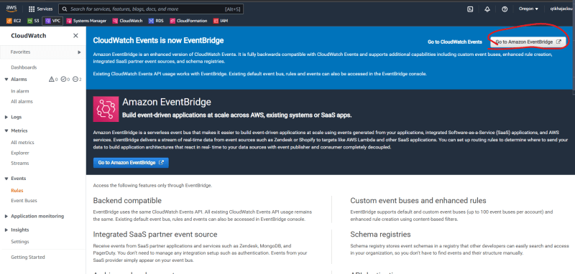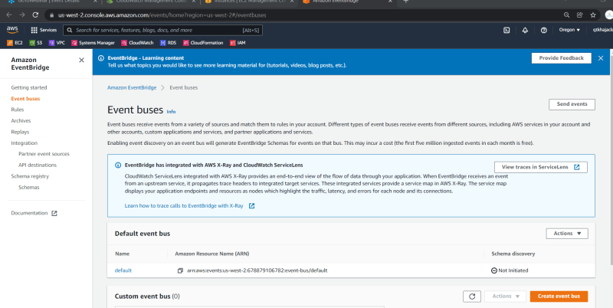
* Cloudwatch events are designed to be able to respond to changes in different AWS resources and services
* Using some rules that determine specific change or action or activity that tookplace, Cloudwatch events can be configured to respond accordingly.
* Amazon EventBridge
  + This is newer version of Amazon CloudWatch Events.
  + Event Bridge is a serverless event bus service that is designed to responds to events by triggering other events
  + Event bridge is very similar to Cloud Watch Events => it recieves events and responds to events from other services
  + Event bridge is different from Cloud Watch Events as it can respind to the events from sources others than AWS Services.
  + Events from Software as a Services or custom applications can be tied to EventBridge and we can respond Accordingly.

Components of Cloudwatch Event:

* + Input Trigger:
    - This is what starts the process or the CloudWatch Event
    - It contains information that is useful for the behavior of the resulting trigger and how the event pattern behaves
    - The input trigger or event source can range from different AWS Services
    - In the Case of Event Bridge, in addition to AWS sources we can also get events from third party
      * PagerDuty
      * Opsgenie
      * Datadog
      * SugarCRM
  + Rule/event pattern:
    - The event pattern gives Cloudwatch Events all the information it needs to react to it
  + Target:
    - This is the destination service that reacts to the input trigger
* Activity: Lets try to use the events to notify the state changes (running -> shutdown etc…)

create a rule 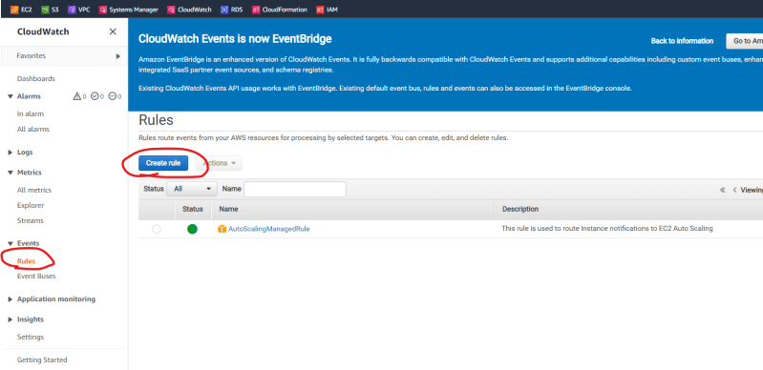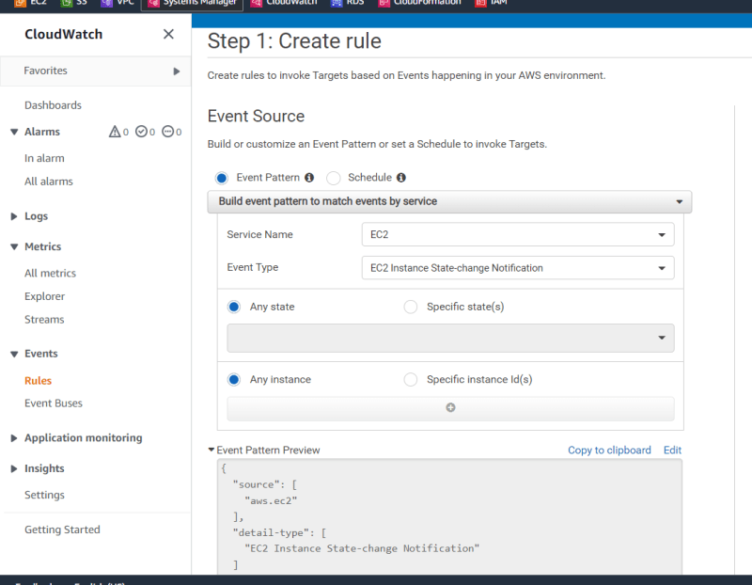

Add a target 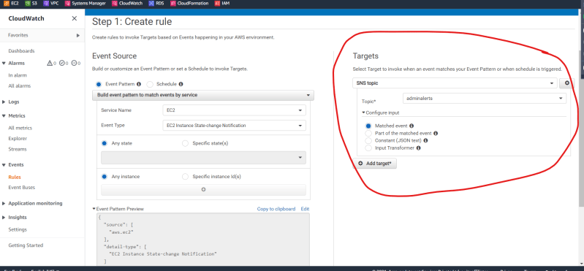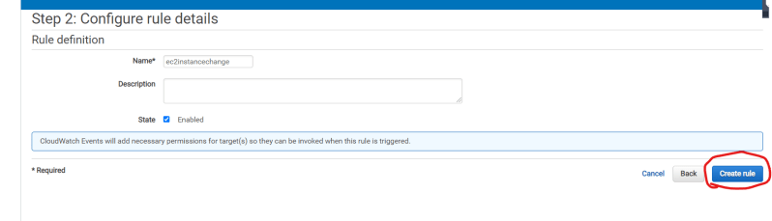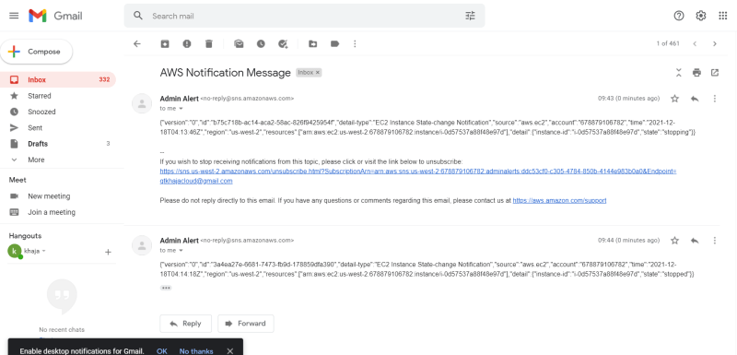

To configure specific instances 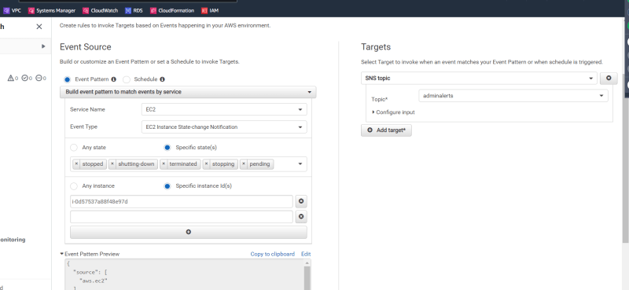

* Activity: Let’s assume your organization wants to start some ec2 instances at 10:00 AM on every working day and shutdown ec2 instances at 7:00 PM to save costs
  + This is where the Schedule will be your input trigger

Let’s try to create cron sytnax 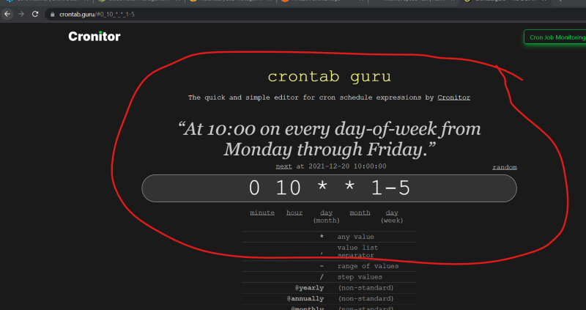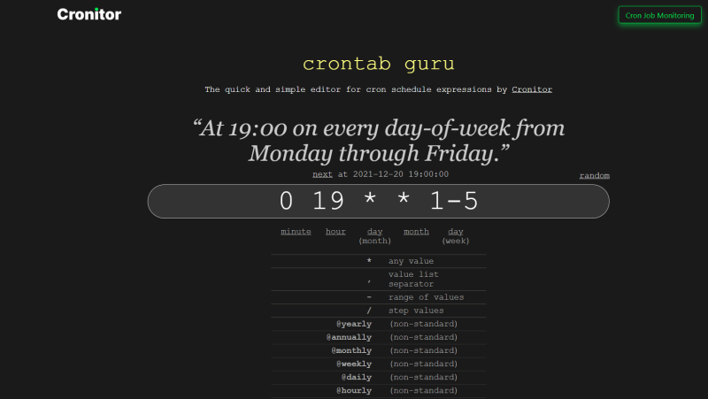

The timezone over here is UTC => Convert to your timezone 